Supplementary Material

Effect of 4-HNE modification on Three-Dimensional Structure of ZU5-ANK domain and interaction with β-spectrin: A Molecular dynamics simulation

Antistio Alviz Amadorª, Rodrigo Galindo-Murillo^{b}, Humberto Pérez Gonzálezª , Erika Rodríguez Cavalloª, Ricardo Vivas Reyes^{c} y Darío Méndez Cuadro*ª

1. Analytical Chemistry and Biomedicine Group. University of Cartagena. Cartagena-Colombia
2. Department of Medicinal Chemistry. University of Utah. Salt Lake. USA
3. Grupo de Química Cuántica y Teórica. University of Cartagena. Cartagena-Colombia

Corresponding author:
E-mail: dmendezc@unicartagena.edu.co.
Tel: + 57 3015584887

Section 1. Superimposition of protein sequences for unmodified and modified ZU5-ANK domain
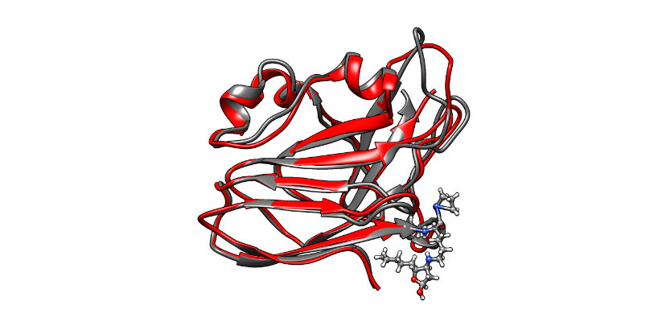
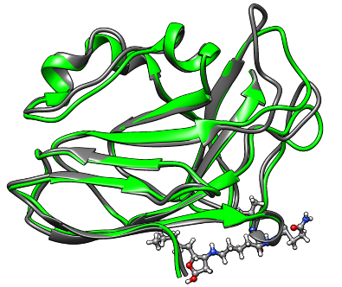
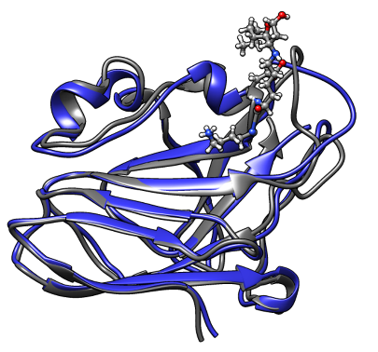
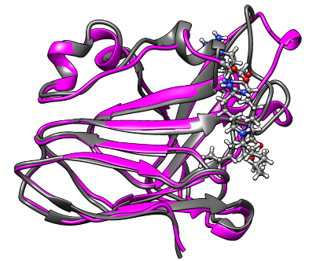
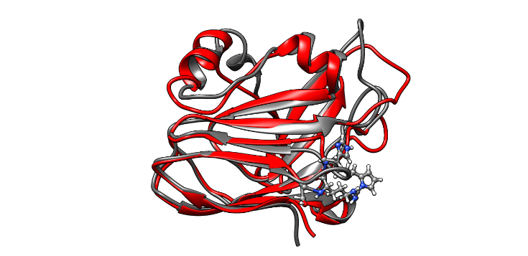
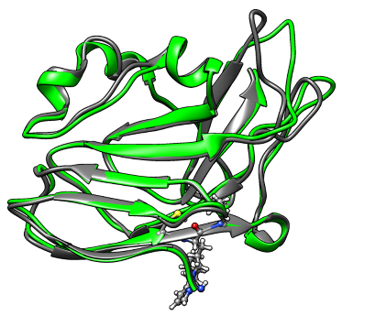
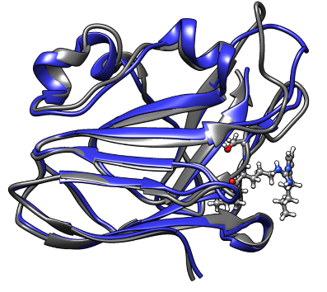
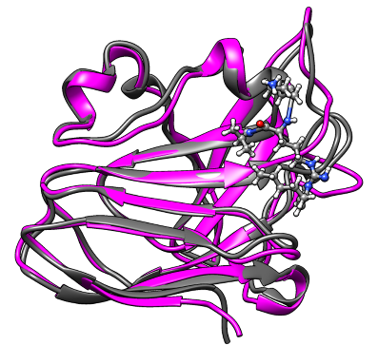
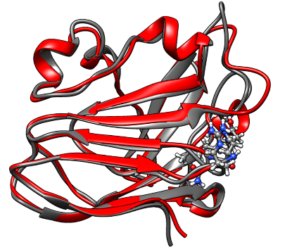
A. ZU5-K44-HNE
B. ZU5-K47-HNE
C. ZU5-K137-HNE
D. ZU5-K137/138-HNE
E. ZU5-R19-HNE
F. ZU5-R41-HNE
G. ZU5-R63-HNE
H. ZU5-R139-HNE
I. ZU5-H20-HNE

Overlay of ZU5-ANK unmodified vs modified | RMSD ( Å)
A. ZU5-K44-HNE | 2.26
B. ZU5-K47-HNE | 2.07
C. ZU5-K137-HNE | 3.25
D. ZU5-K137/138-HNE | 3.919
E. ZU5-R19-HNE | 2.46
F. ZU5-R41-HNE | 2.12
G. ZU5-R63-HNE | 1.81
H. ZU5-R139-HNE | 1.98
I. ZU5-H20-HNE | 1.96

Figure 5. Superimposition of protein sequences for unmodified and modified ZU5-ANK domain of most representives clusters.
Section 2. Full Clustering Results of ZU5-ANK domain Trajectories.

Table S1. Clustering Analysis ZU5-ANK unmodified and modified

ZU5-ANK
#Cluster | Frames | Frac | AvgDist | Stdev | AvgCDist
0 | 61349 | 0,303 | 2.033 | 0.421 | 2.786
1 | 30148 | 0,209 | 1.989 | 0.377 | 2.912
2 | 27163 | 0,134 | 2.010 | 0.411 | 2.849
3 | 26961 | 0,133 | 1.933 | 0.392 | 3.001
4 | 20767 | 0,103 | 2.229 | 0.386 | 2.982
5 | 16389 | 0,08 | 1.954 | 0.362 | 2.866
6 | 15615 | 0,03 | 2.070 | 0.399 | 3.103
7 | 2213 | 0,001 | 1.988 | 0.455 | 3.193
8 | 1656 | 0,007 | 1.697 | 0.325 | 3.039
9 | 72 | 0 | 0.000 | 0.000 | 3.375

ZU5-k44-HNE
#Cluster | Frames | Frac | AvgDist | Stdev | AvgCDist
0 | 93132 | 0.683 | 2.401 | 0.482 | 3.388
1 | 10761 | 0.079 | 2.472 | 0.473 | 3.499
2 | 8283 | 0.061 | 2.078 | 0.415 | 3.359
3 | 8219 | 0.060 | 2.172 | 0.478 | 3.566
4 | 6065 | 0.045 | 1.326 | 0.200 | 3.792
5 | 3520 | 0.026 | 1.981 | 0.356 | 4.394
6 | 2190 | 0.016 | 2.066 | 0.385 | 3.625
7 | 2157 | 0.016 | 2.089 | 0.445 | 3.643
8 | 1701 | 0.012 | 2.321 | 0.542 | 3.764
9 | 242 | 0.002 | 2.101 | 0.480 | 3.871

ZU5-k47-HNE
#Cluster | Frames | Frac | AvgDist | Stdev | AvgCDist
0 | 106078 | 0.833 | 2.337 | 0.392 | 2.852
1 | 9153 | 0.072 | 1.848 | 0.399 | 3.225
2 | 4422 | 0.035 | 1.904 | 0.348 | 3.006
3 | 1871 | 0.015 | 1.566 | 0.338 | 3.097
4 | 1607 | 0.013 | 1.726 | 0.465 | 3.044
5 | 1555 | 0.012 | 2.103 | 0.470 | 3.589
6 | 1297 | 0.010 | 1.487 | 0.309 | 3.236
7 | 675 | 0.005 | 1.619 | 0.413 | 3.047
8 | 422 | 0.003 | 1.669 | 0.336 | 3.215
9 | 252 | 0.002 | 2.004 | 0.556 | 3.050

ZU5-k137-HNE
#Cluster | Frames | Frac | AvgDist | Stdev | AvgCDist
0 | 35704 | 0.443 | 2.141 | 0.364 | 3.037
1 | 22899 | 0.284 | 1.987 | 0.403 | 3.528
2 | 6718 | 0.083 | 1.768 | 0.417 | 3.263
3 | 5353 | 0.066 | 2.079 | 0.378 | 3.137
4 | 5073 | 0.063 | 1.967 | 0.521 | 3.087
5 | 1980 | 0.025 | 1.957 | 0.409 | 3.196
6 | 1387 | 0.017 | 1.514 | 0.249 | 3.348
7 | 835 | 0.010 | 1.550 | 0.244 | 3.373
8 | 549 | 0.007 | 1.474 | 0.531 | 3.280
9 | 33 | 0.000 | 0.000 | 0.000 | 3.901

ZU5-K137/138-HNE
#Cluster | Frames | Frac | AvgDist | Stdev | AvgCDist
0 | 50563 | 0.404 | 2.536 | 0.525 | 3.671
1 | 20391 | 0.163 | 2.387 | 0.574 | 3.293
2 | 17723 | 0.142 | 2.420 | 0.551 | 3.375
3 | 9973 | 0.080 | 2.228 | 0.483 | 3.469
4 | 9761 | 0.078 | 2.168 | 0.476 | 3.306
5 | 9461 | 0.076 | 2.609 | 0.497 | 3.605
6 | 4785 | 0.038 | 2.400 | 0.490 | 3.257
7 | 1467 | 0.012 | 2.108 | 0.483 | 3.477
8 | 823 | 0.007 | 1.897 | 0.409 | 3.466

ZU5-R19-HNE
#Cluster | Frames | Frac | AvgDist | Stdev | AvgCDist
0 | 39097 | 0.383 | 2.327 | 0.418 | 2.959
1 | 25610 | 0.251 | 2.213 | 0.397 | 2.978
2 | 17420 | 0.171 | 2.146 | 0.400 | 3.093
3 | 10031 | 0.098 | 1.855 | 0.329 | 3.059
4 | 4051 | 0.040 | 2.204 | 0.506 | 3.126
5 | 2714 | 0.027 | 1.853 | 0.349 | 3.294
6 | 1735 | 0.017 | 1.900 | 0.448 | 3.059
7 | 661 | 0.006 | 1.669 | 0.411 | 3.307
8 | 476 | 0.005 | 1.901 | 0.575 | 3.150
9 | 214 | 0.002 | 1.485 | 0.371 | 3.219

ZU5-R41-HNE
#Cluster | Frames | Frac | AvgDist | Stdev | AvgCDist
0 | 106821 | 0.693 | 2.467 | 0.432 | 3.394
1 | 14473 | 0.094 | 2.319 | 0.401 | 3.422
2 | 12646 | 0.082 | 2.305 | 0.446 | 3.384
3 | 6533 | 0.042 | 2.158 | 0.435 | 3.524
4 | 5180 | 0.034 | 2.406 | 0.511 | 3.497
5 | 3085 | 0.020 | 2.331 | 0.483 | 3.477
6 | 2427 | 0.016 | 1.884 | 0.392 | 3.522
7 | 1703 | 0.011 | 2.080 | 0.481 | 3.427
8 | 1220 | 0.008 | 1.674 | 0.473 | 3.253
9 | 24 | 0.000 | 0.000 | 0.000 | 3.557

ZU5-R63-HNE
#Cluster | Frames | Frac | AvgDist | Stdev | AvgCDist
0 | 98468 | 0.742 | 2.046 | 0.369 | 2.921
1 | 12843 | 0.097 | 2.011 | 0.340 | 2.811
2 | 8168 | 0.062 | 1.741 | 0.313 | 2.925
3 | 4578 | 0.035 | 1.801 | 0.324 | 2.957
4 | 2983 | 0.022 | 1.221 | 0.136 | 3.275
5 | 2953 | 0.022 | 1.916 | 0.341 | 2.959
6 | 1487 | 0.011 | 1.835 | 0.415 | 3.009
7 | 713 | 0.005 | 1.238 | 0.248 | 3.092
8 | 389 | 0.003 | 1.593 | 0.297 | 3.322
9 | 68 | 0.001 | 0.000 | 0.000 | 3.346

ZU5-R139-HNE
#Cluster | Frames | Frac | AvgDist | Stdev | AvgCDist
0 | 31521 | 0.201 | 1.749 | 0.558 | 3.527
1 | 27612 | 0.176 | 2.497 | 0.590 | 3.884
2 | 27514 | 0.176 | 2.200 | 0.513 | 4.071
3 | 24714 | 0.158 | 2.545 | 0.580 | 3.773
4 | 18130 | 0.116 | 2.442 | 0.555 | 3.640
5 | 12618 | 0.081 | 2.408 | 0.464 | 3.824
6 | 10760 | 0.069 | 2.692 | 0.514 | 3.798
7 | 2648 | 0.017 | 2.112 | 0.584 | 3.797
8 | 575 | 0.004 | 1.747 | 0.309 | 4.248
9 | 376 | 0.002 | 1.823 | 0.350 | 4.002

ZU5-H20-HNE
#Cluster | Frames | Frac | AvgDist | Stdev | AvgCDist
0 | 43287 | 0.457 | 1.883 | 0.363 | 2.557
1 | 18071 | 0.191 | 1.702 | 0.334 | 2.945
2 | 16229 | 0.171 | 2.050 | 0.380 | 2.694
3 | 13398 | 0.142 | 1.813 | 0.275 | 2.672
4 | 2514 | 0.027 | 1.684 | 0.490 | 2.840
5 | 530 | 0.006 | 1.565 | 0.398 | 2.805
6 | 349 | 0.004 | 1.748 | 0.462 | 3.134
7 | 258 | 0.003 | 1.105 | 0.140 | 2.959
8 | 24 | 0.000 | 0.000 | 0.000 | 3.088
9 | 23 | 0.000 | 0.000 | 0.000 | 2.903

Fig S1. Proteins population’s figures () obtained of Clustering Analysis using the Hieragglo algorithm. A. ZU5-, B. ZU5-K44-4HNE C. ZU5-K47-4HNE, D. ZU5-K137-4HNE, E. ZU4-K137/138-4HNE

Section 3. Full Clustering Results of ZU5-ANK domain Trajectories.

Fig S2. ZU5-ANK domain population’s figures obtained of Clustering Analysis using the Hieragglo algorithm. A. ZU5-R19-4HNE, B. ZU5-R41-4HNE C. ZU5-R63-4HNE, D. ZU5-R139-4HNE, E. ZU5-H20-4HNE

Section 3. Full Clustering Results of ZU5-ANKSpectrin complexes Trajectories.

ZU5-SPEC-NATIVE COMPLEX

#Cluster | Frames | Frac | AvgDist | Stdev | AvgCDist
0 | 4623 | 0.456 | 2.527 | 0.483 | 4.207
1 | 2210 | 0.218 | 2.474 | 0.469 | 4.205
2 | 1779 | 0.175 | 2.492 | 0.653 | 4.160
3 | 615 | 0.061 | 2.801 | 0.000 | 5.287
4 | 310 | 0.031 | 2.057 | 0.000 | 5.257
5 | 287 | 0.028 | 0.000 | 0.000 | 4.167
6 | 119 | 0.012 | 0.000 | 0.000 | 4.242
7 | 96 | 0.009 | 0.000 | 0.000 | 4.284
8 | 65 | 0.006 | 2.318 | 0.000 | 5.090
9 | 43 | 0.004 | 0.000 | 0.000 | 4.903

ZU5-K137*HNE-SPEC-NATIVE COMPLEX
#Cluster | Frames | Frac | AvgDist | Stdev | AvgCDist
0 | 3277 | 0.330 | 2.419 | 0.379 | 3.559
1 | 1941 | 0.195 | 2.495 | 0.410 | 3.661
2 | 1640 | 0.165 | 2.495 | 0.421 | 3.491
3 | 688 | 0.069 | 2.227 | 0.326 | 4.386
4 | 610 | 0.061 | 2.256 | 0.284 | 4.006
5 | 581 | 0.058 | 2.455 | 0.423 | 4.054
6 | 508 | 0.051 | 2.483 | 0.204 | 3.977
7 | 249 | 0.025 | 2.402 | 0.357 | 4.910
8 | 220 | 0.022 | 0.000 | 0.000 | 4.380
9 | 218 | 0.022 | 2.007 | 0.000 | 4.232

ZU5-K137/138*HNE-SPEC-NATIVE COMPLEX
Cluster | Frames | Frac | AvgDist | Stdev | AvgCDist
0 | 4073 | 0.403 | 2.364 | 0.405 | 3.299
1 | 2245 | 0.222 | 2.254 | 0.305 | 3.316
2 | 1129 | 0.112 | 2.095 | 0.337 | 3.340
3 | 852 | 0.084 | 2.272 | 0.000 | 3.895
4 | 540 | 0.053 | 2.357 | 0.372 | 3.828
5 | 436 | 0.043 | 2.310 | 0.206 | 3.976
6 | 386 | 0.038 | 2.323 | 0.340 | 4.202
7 | 313 | 0.031 | 2.129 | 0.000 | 3.702
8 | 82 | 0.008 | 0.000 | 0.000 | 4.678
9 | 54 | 0.005 | 0.000 | 0.000 | 3.830

Fig S3. ZU5-ANK-Spectrin complexes protein population’s figures () obtained of Clustering Analysis using the Hieragglo algorithm. A. ZU5-ANK-Spectrin (native), B. ZU5-(K*137HNE)-Spectrin C. ZU5-(K*137/138HNE)-Spectrin.

